Graphic Processing

Project

Cadar Andrei Calin

Group 30432

1. Contents

2. Subject specification………………………………………………………………………….3

3. Scenario………………….………………………………………………………………………….3

4.Implementation details……………………………………………………………………….3

5.User interface manual………………………………………………………………………….15

6.Further developments………………………………………………………………………….16

7.Conclusions………………………………………………………………………………………….16

8.References………………………………………………………………………………….……….17

1. Subject specification

The subject of this project is a photorealistic presentation of a scene made using OpenGL library in C++. OpenGL (Open Graphics Library) is a cross-language API for rendering 2D and 3D vector graphics. The API is typically used to interact with a GPU to achieve hardware-accelerated rendering. To illustrate how many can be done using OpenGL with little effort I have developed a scene with various functionalities and features.

1. Scenario
   1. Scene and objects description

My scene does not particularly have a story behind it, but the objects are not randomly placed either. Some of them are connected, for example I have an old TV which acts like a CCTV camera and I have a CCTV camera on a pole.

To start from the beginning I have a cube which acts as the ground for the player to move on. There are 12 post lamps composed out of three objects:

* Pole
* Main light part
* 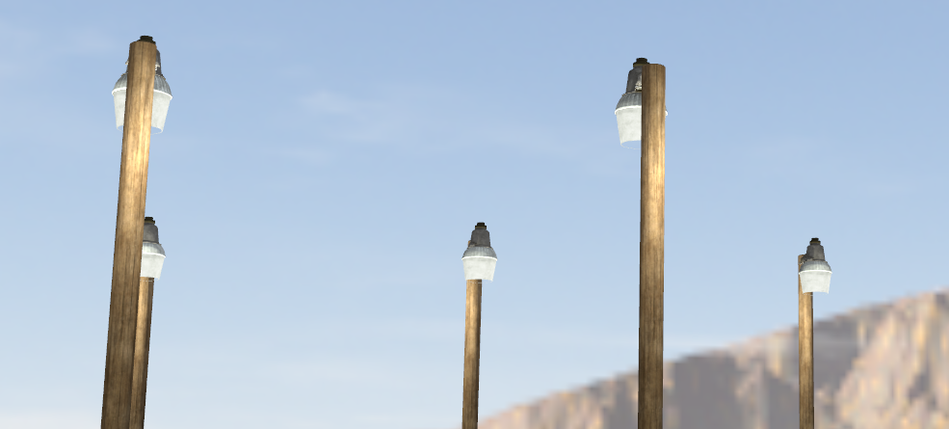Glowing part of the light

These lamps are the main light source during the night, but it can be easily seen they emit light during the day too.

There is also a 13th post lamp which also has a spotlight attached to it, besides its main pointlight, to illustrate the differences between them.

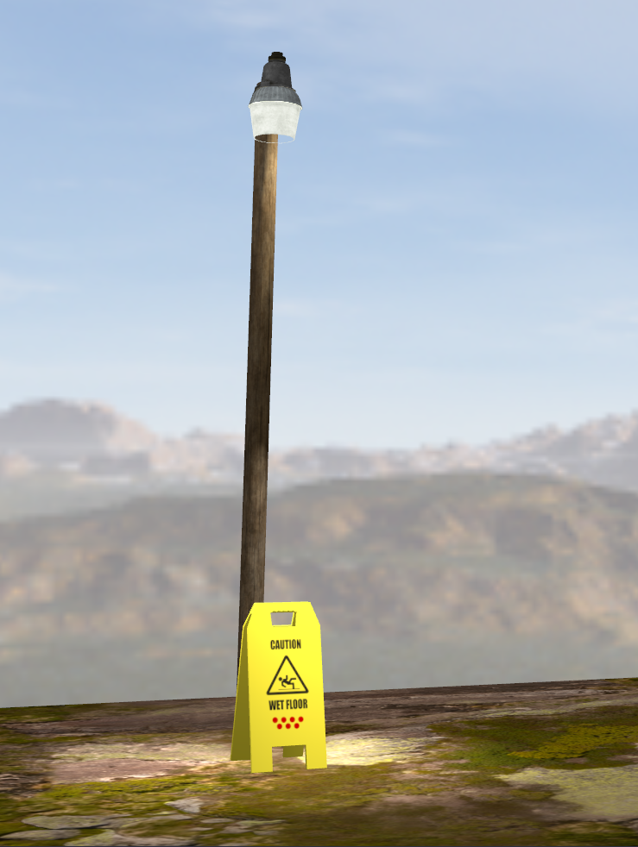

In the upper-right corner of the scene we have a fireplace which was custom made. I have downloaded models of logs and stones and placed each one of them manually. I have scaled and rotated them so it has a more natural look.

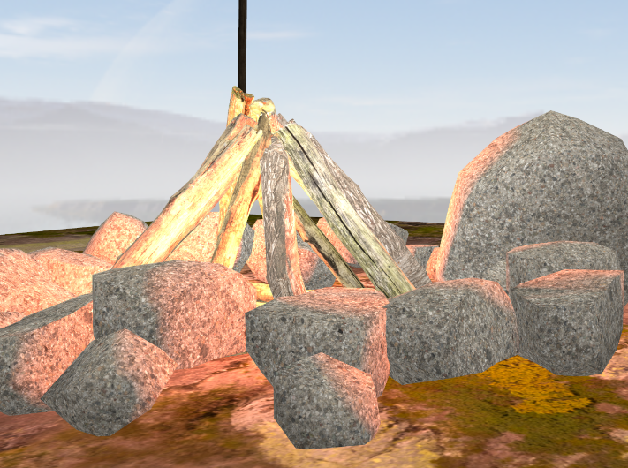

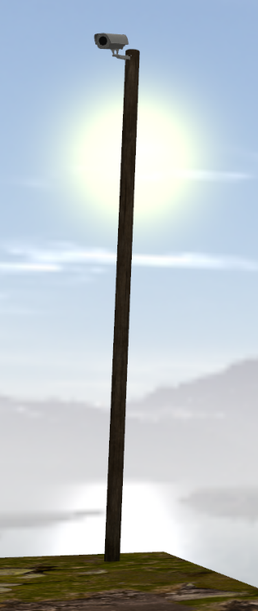 Right in the same corner there is a post which has the CCTV camera attached to it.

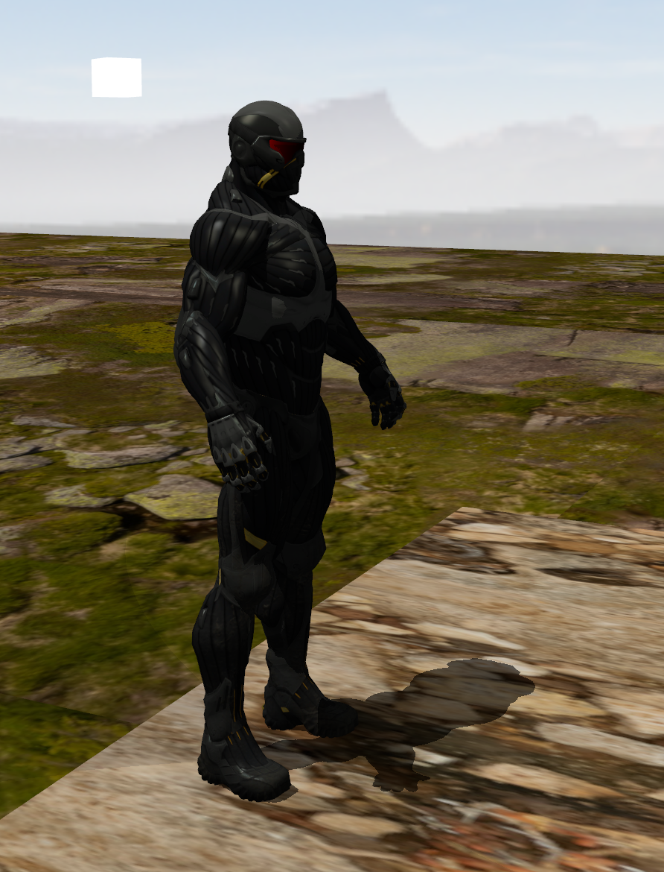 In the scene the famous nanosuit from the lab is also present with a floating white cube to help us exemplify the direction of the directional light and the shadows.

In the room where the TV is located there are also 7 light bulbs each one having one color of the rainbow.

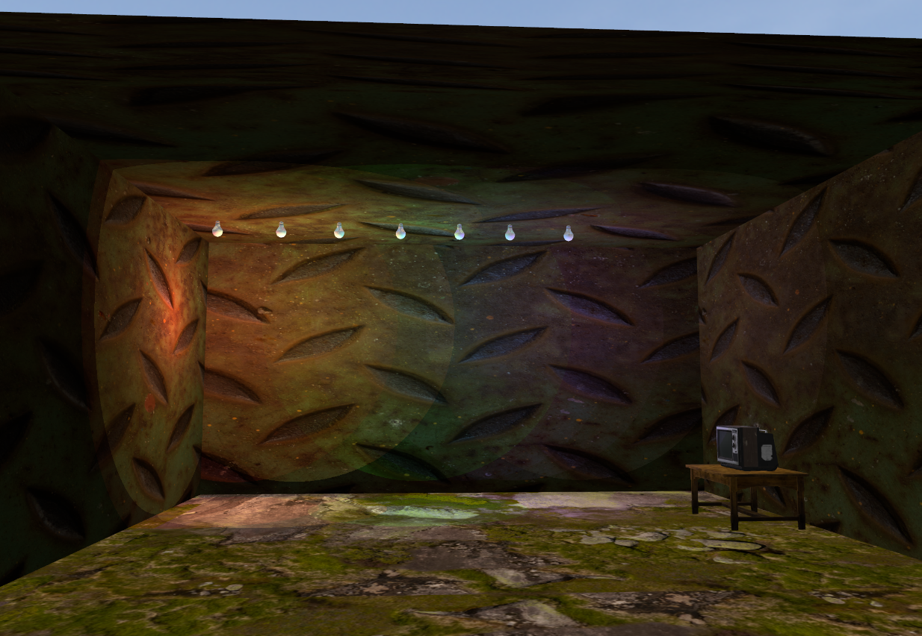

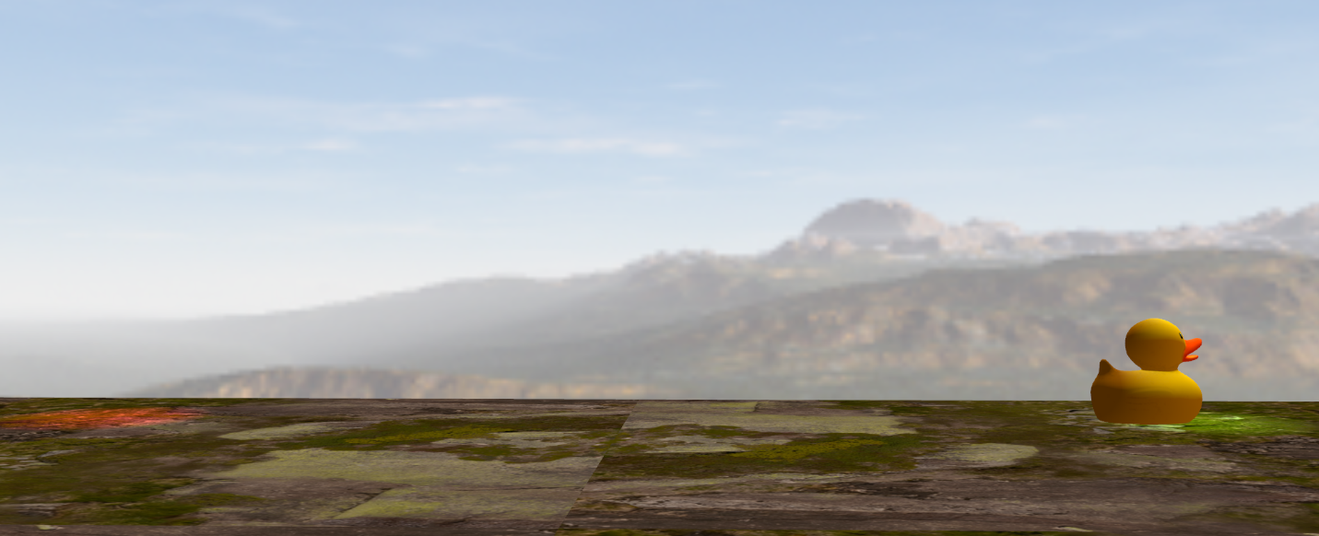What better way to exemplify animations than a rubber duck moving between two spot lights?

* 1. Functionalities

First of all, the application is like a small First Person 3D game. The user/player can move in the scene using W, A, S and D for movement, it can also sprint and crouch.

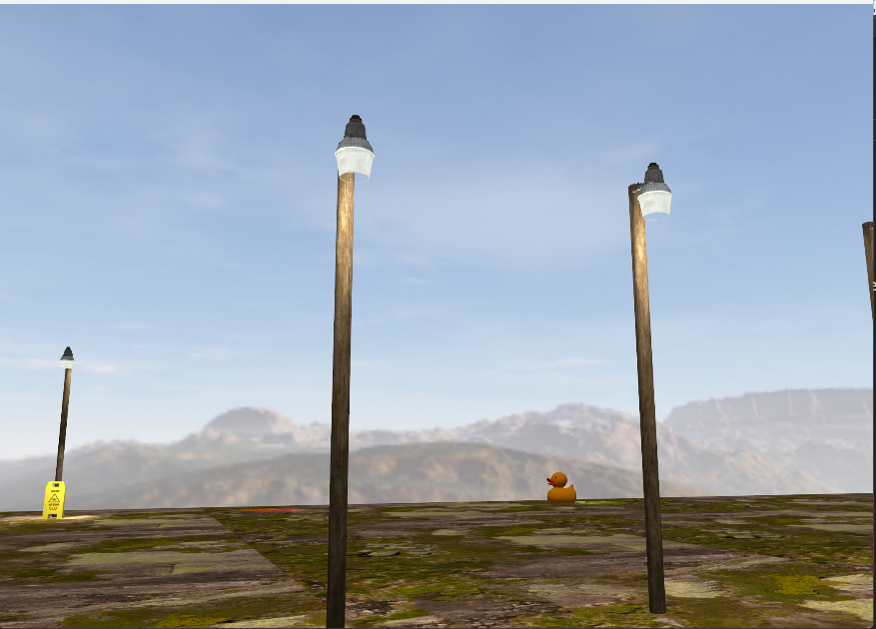Another thing that the player can do is to change the day from day to night or reverse.

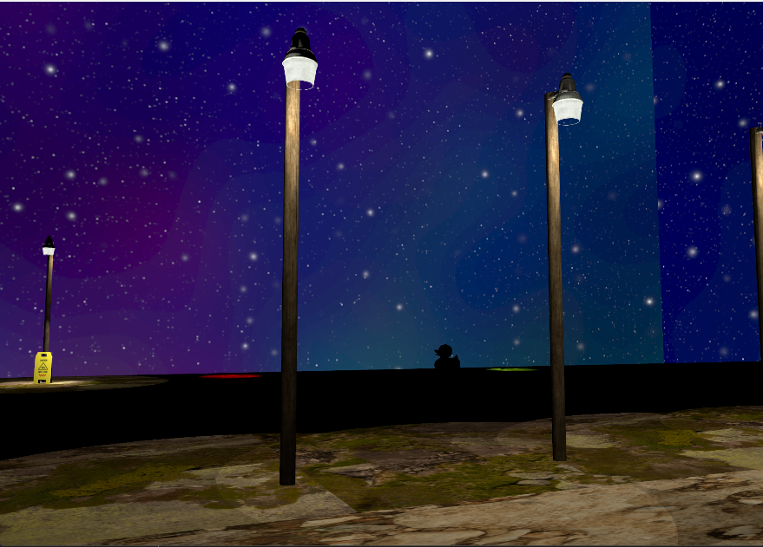

Because we have night in the game, of course we need a flashlight which can also be toggled on or off.

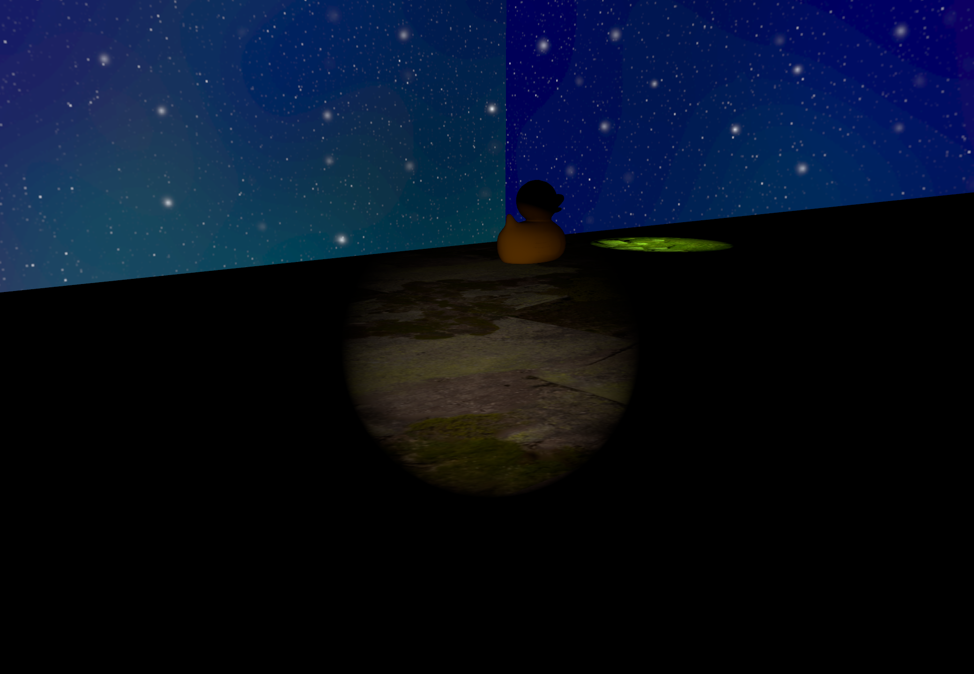

What photorealistic scene is one without fog? The user can also toggle the fog or off. There are two types of fog, one for the day time and one for the night time, since the day time one needs a brighter color.

We can see that the fog matches perfectly with the skybox’s blurred mountains and sun.

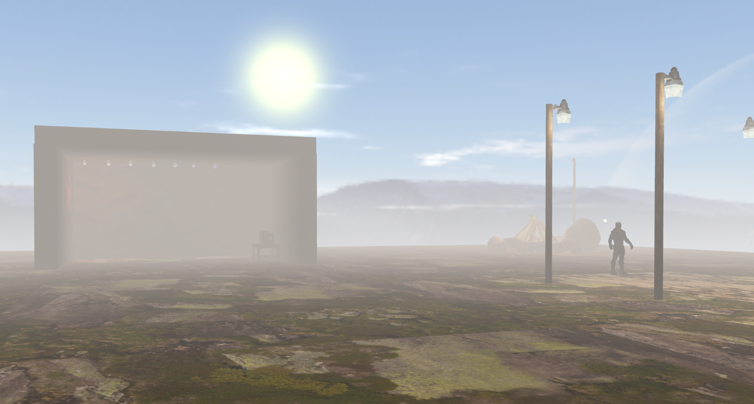

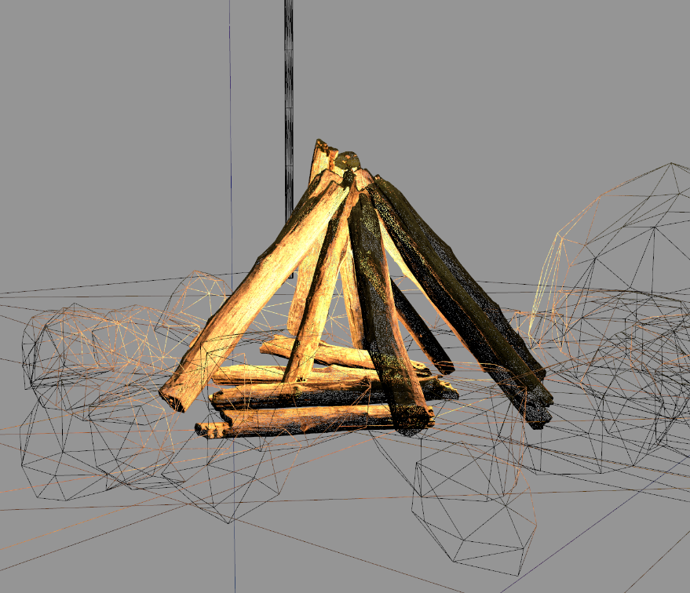Another nice feature of the game is the possibility to see wireframes of the objects. We see that the light is also rendered on the lines and how detailed some objects are, for example the logs.

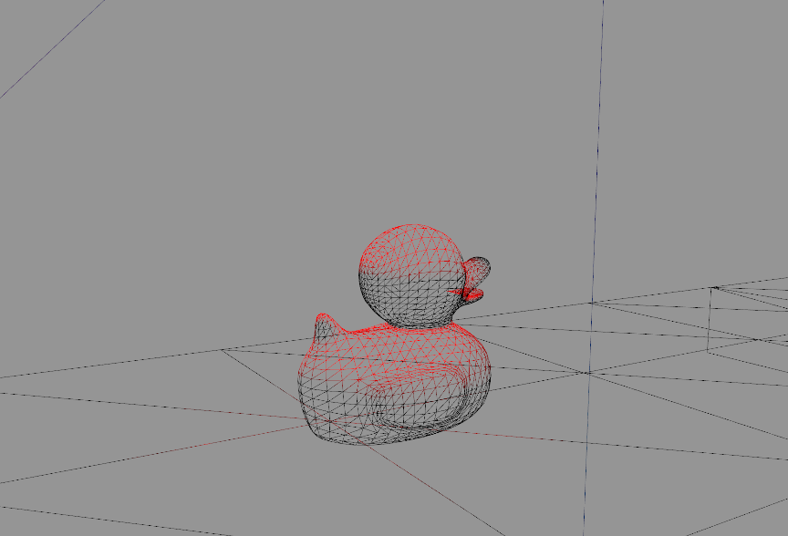

We can also view the shadow depth map of the nanosuit. Both the nanosuit and the directional light, represented by the cube surrounding the nanosuit can be rotated by the user from the keyboard.

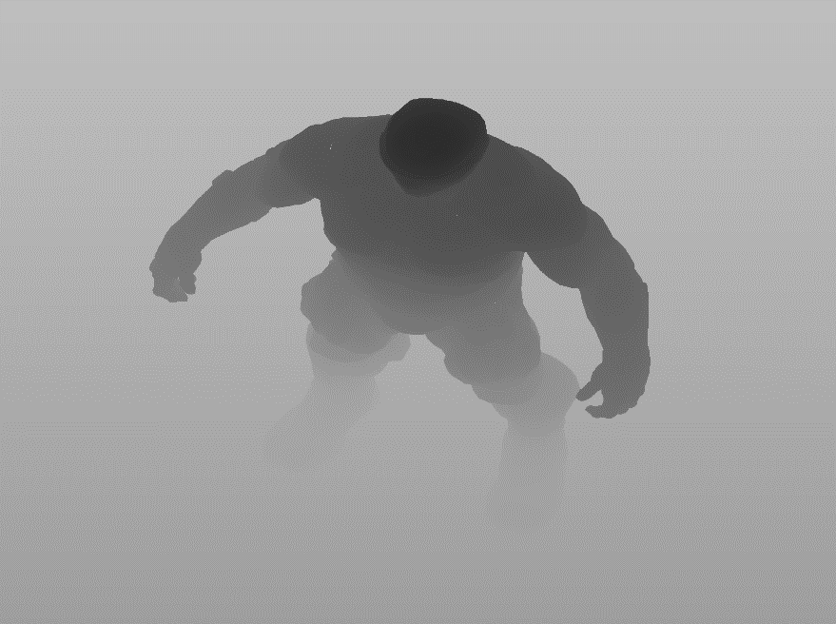

1. Implementation details

The scene starts with an animation in which the majority of the scene is presented, like a cutscene in games. The user cannot interact with the application while the cutscene is running.

4.1 Animation

For the animation I have implemented a state machine that changes between multiple keyframes of the animation. Between each two keyframes each animated object has one of its attributes modified by a function of this type:

*Object.attribute = glm::mix(value1, value2, elapsedTime);*

**glm::mix** makes a linear interpolation between value 1 and value2.

**elapsedTime,** which is the range of [0, 1] is incremented every frame with **deltaTime*speed** where deltaTime is the time interval between two rendered frames. This way we can change the animation speed by changing the **speed** parameter.

When elapsedTime reaches 1, we move to the next animation state. For the first 2 animation states I do not only move and rotate the camera but also change the directional light intensity and change the skyboxes to make it feel like a full day-night cycle.

For the duck animation a separate algorithm was needed because it is happening in a loop all the time while the app is running.

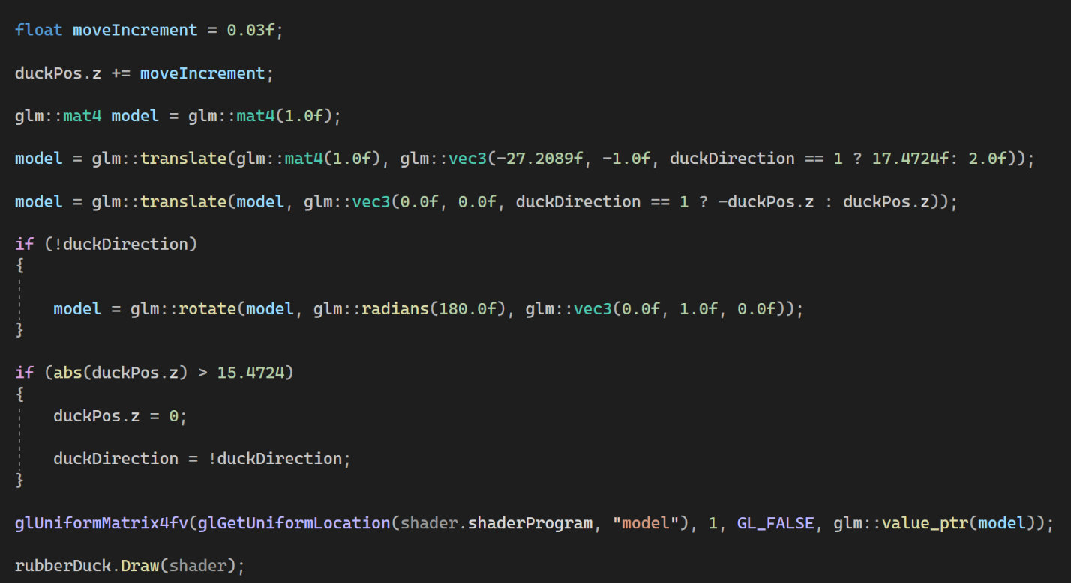

The lights from the fire are also animated to mimic a pulsating light from the fire, each of the properties having a different speed of looping to make them more natural.

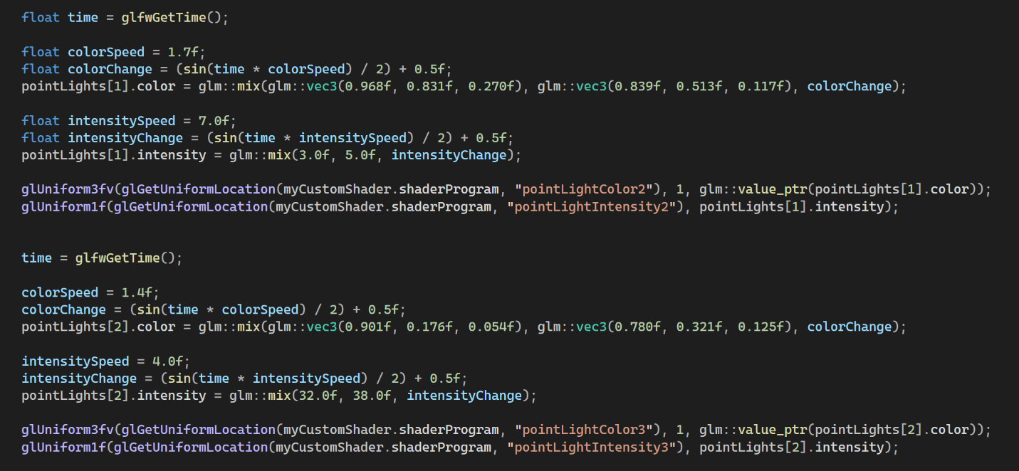

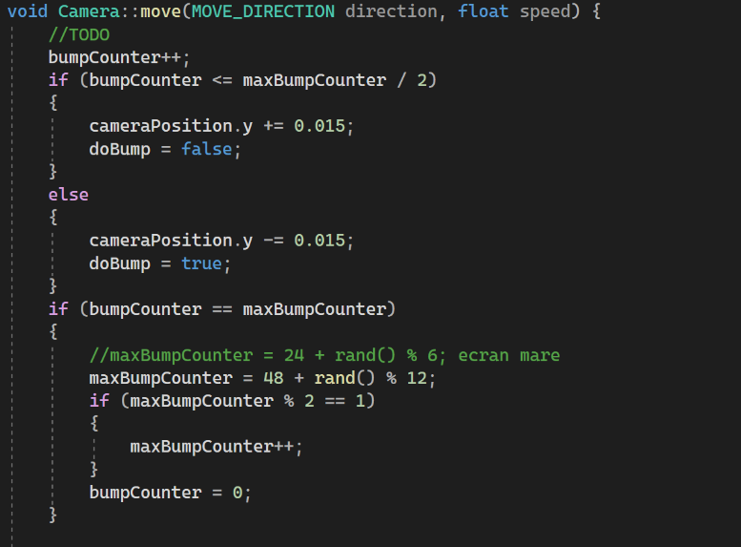There is also a small animation happening when the player moves. The camera moves a bit up and down to mimic a natural movement of a person. This extra movement is computed in the **move** function of the camera.

4.2 Collision detection

When the player is inside a square in the (x,z) plane in front of the TV and presses a button it switches the camera view to the CCTV camera. In this view mode he cannot move, or move the camera on the Y axis and also its sensitivity is reduced. Press that key again and get back to first person mode.

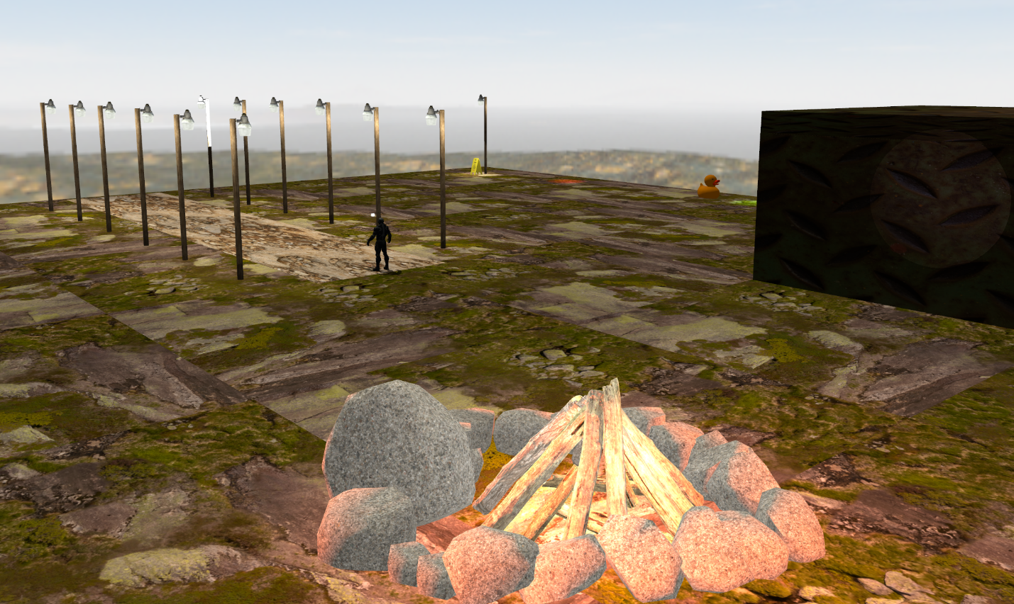

Later I also added collision detection for the map edges, what game is one which lets you wonder outside the map? This was straight forward to implement

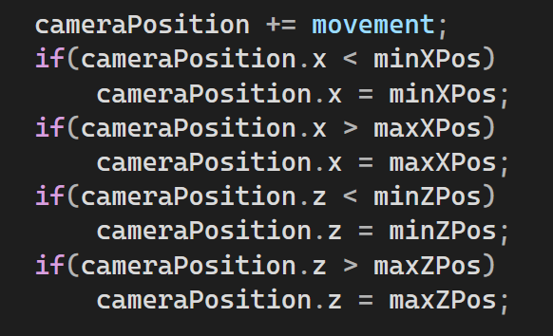

4.3 Lights

In the scene we have 3 different types of lights:

1. Directional
2. Point light
3. Spotlight

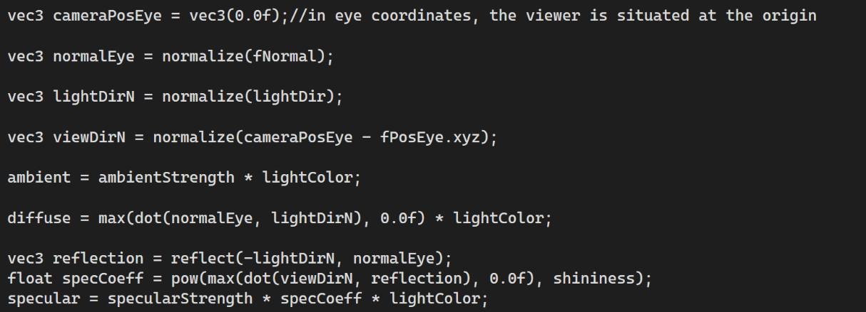The influence of the directional light on a fragment is calculated as thought in the laboratory.

The normal of each fragment is computed based on camera’s position and the position of the fragment in eye space.

The influence of the point lights on the fragments is computed in the following way:

This computation is done for every point light in the scene. One major difference is that now we use the fragment’s position in the world space. For that we needed to modify a bit also the vertex shader to include this line:

fragPos = (model * vec4(vPosition, 1.0f)).xyz;

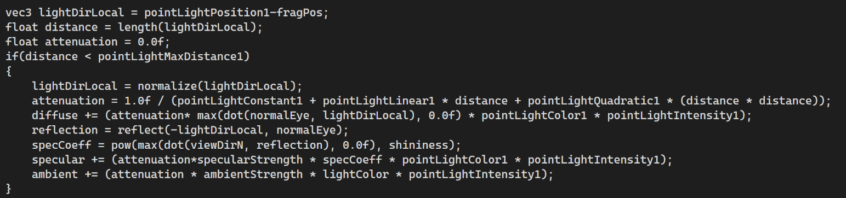

First of all, this type of light has a few more parameters like:

* maxDistance
* constant
* linear
* quadratic
* intensity

**maxDistance** is used for efficiency purposes because by default all these operations are done by every fragment for every light, even if there influence in the texture components is almost 0.

**constant, linear and quadratic** are used in the computation of the attenuation component to mimic the light intensity dependency in real life.

**Intensity** is used to fine tune the light’s “power”. As I needed in many cases throughout the project a light which is dimmed on the edges but very powerful to the center.

A spotlight is a sub-type of a pointlight, for spotlights we have two extra parameters :

* direction
* cutOff

If a point light is a point which emits light all around it, in 3D, we can imagine a spotlight as cut-off in that sphere, that would be a cone of light. To calculate which surface of the sphere should be illuminated we need a direction and a cut-off angle. To calculate the **cutOff** we simply calculate the **cos** of the desired angle. Then we need to compare the **spotFactor** with the cutoff to determine if we load the image. We render if **spotFactor > cutOff**.

**spotFactor = dot(lightDirLocal, spotLightDirection);**

I have also implemented **HDR**, with the purpose of further implementing **bloom** using Gausian Blur, which I did not succeed. The lower part of the post lamps objects have the **HDR** shader and one of the lights very bright **(100.0f, 100.0f, 100.0f)** to show that the texture is not over-exposed.

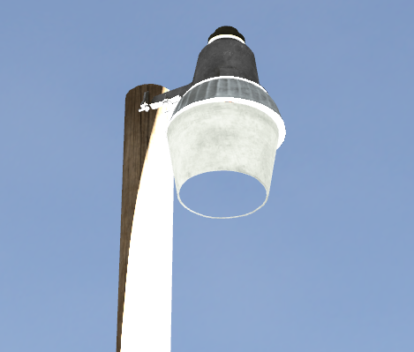

4.4 Graphics model

In constructing the graphics model for my OpenGL project, I sourced various free objects and textures online. Using Blender, I methodically applied textures to objects, ensuring a cohesive arrangement before exporting to my OpenGL scene. During this process I learned a lot of tricks in Blender that would help me in possible future games that I would develop.

4.5 Data structures

I have mostly used data structures from the OpenGL library but also made some custom structures for the point light and the spotlight.

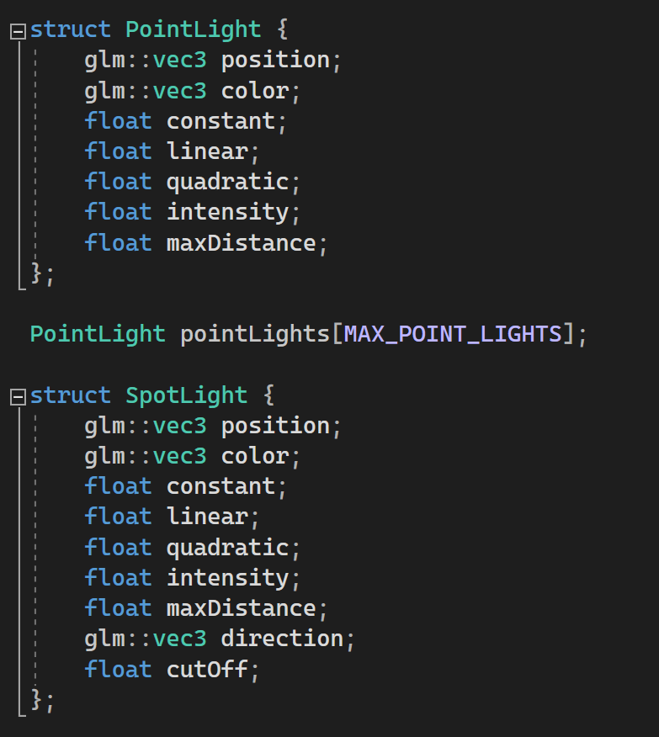

I have also defined extra functions and variables defined inside **Camera.cpp**.

4.5 Class hierarchy

* main.cpp – main rendering happens here, all the uniform variables of the shaders are sent here
* Camera.cpp – controls movement and rotation of the camera
* Shader.cpp – responsible for loading the shaders
* SkyBox.cpp – loads the skybox from the files

1. User interface manual

* ESC -> exits the app
* M -> toggles shadow map
* Q -> rotate nanosuit on Y axis negative
* E -> rotate nanosuit on Y axis positive
* J -> rotate directional light on Y axis negative
* L -> rotate directional light on Y axis posiitve
* G -> toggle fog
* F -> toggle flashlight
* X -> change between day and night
* W -> move forward
* A -> move to the left
* S -> move backward
* D -> move to the right
* Shift -> sprint
* LCtrl -> toggle crouch
* V -> toggle camera view
* T -> toggle wireframe/solid object view

1. Further developments

As further developments I would really like to solve my issue with blooming and also it would be nice to add rain particles and fire particles to the fire pit. I would like also to add HDR capable shader to every object in the scene.

1. Conclusions

I had a lot of fun while developing this project. I have made a lot of games in the Unity game engine starting from 5th grade up until the 11th grade, all sorts 2D, 3D, horror, RPG, FPS but only now I can fully understand how textures are mapped, what each type of lighting object in Unity actual represents, what are materials, shaders and a lot more. Moreover, I understand how many computations are done behind in the GPU and how many optimizations and tricks are done behind the scene for the GPU to be able to render the scene to the user.

1. References

* <https://moodle.cs.utcluj.ro/course/view.php?id=613>
* <https://www.youtube.com/watch?v=MAJqiDll0a8&pp=ygUSb3BlbiBnbCBzcG90bGlnaHRz>
* <https://learnopengl.com/Advanced-Lighting/HDR>
* https://learnopengl.com/Advanced-Lighting/Bloom